I was astounded by what I was able to observe after exploring the data of ski resorts all over the country and then creating a model to try to predict ticket prices. The current ticket prices for Big Mountain are 81$ but they are based solely on the nearby competition. The current model for ticket pricing doesn’t take into consideration what features customers value in a ski resort. Based on the correlation heatmap provided below, it was determined that the features that most influence ticket prices for all resorts around the country include: Runs, fastQuads, vertical drop, snow making, longest runs, total chairs, and skiable terrain. 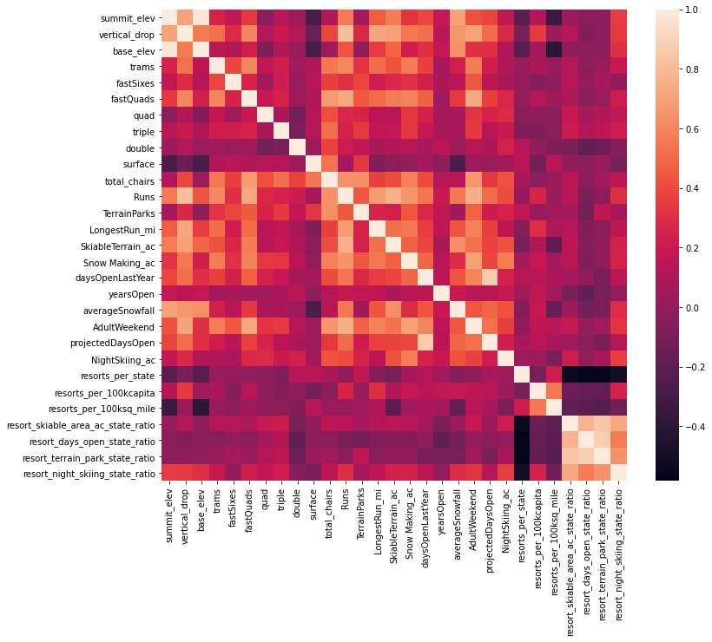

After creating this heatmap and establishing the popular features that customers look forward to, I was able to create a model based on the average prices of other ski resorts around the country in relation to the quantity of desired features that these resorts have. When applying this model to Big Mountain resort, the model predicted that our ticket price should be ~95$. This is due to the resort containing high amounts of the desired features that customers crave for. We also tested that the model has an error of ~9$. I suggest that we at the very least increase the price of our tickets by 5$ to at the very least stay in line with the error. By doing this, we would easily be able to recover the losses obtained from adding a new chair lift.

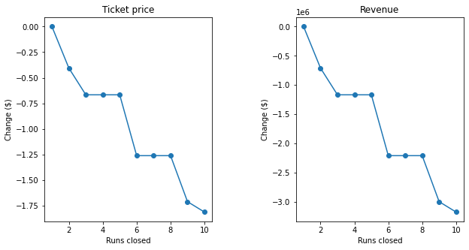

In addition, the graphs above show what would happen if the resort were to close runs. From what we can observe, there is a steep decline in ticket price and revenue when closing 1, 2, and 3 runs. If we have already closed 3 runs however, then we might as well close 5 total runs because based on our model, it will have no effect on ticket price or revenue. The graph below shows us how we compare to other resorts in terms of available runs.

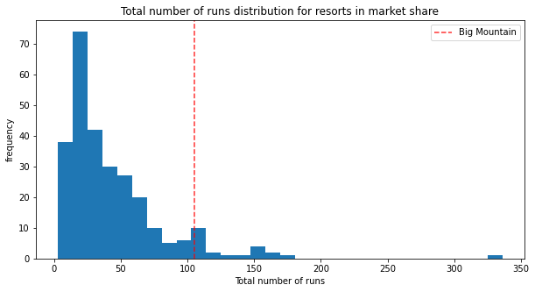

This table shows how Big Mountain is one of the few resorts with lots of runs. Again this is a feature that customers desire a lot of. I believe that our company does not need to increase or decrease the amount of runs we currently have.